

*Bouncing Balls: Validation Test

Name: ______________________________________

Teacher: ____________________________________

The following test refers to the Bouncing Balls investigation that you completed in class last week.

Please complete all questions in the spaces provided.

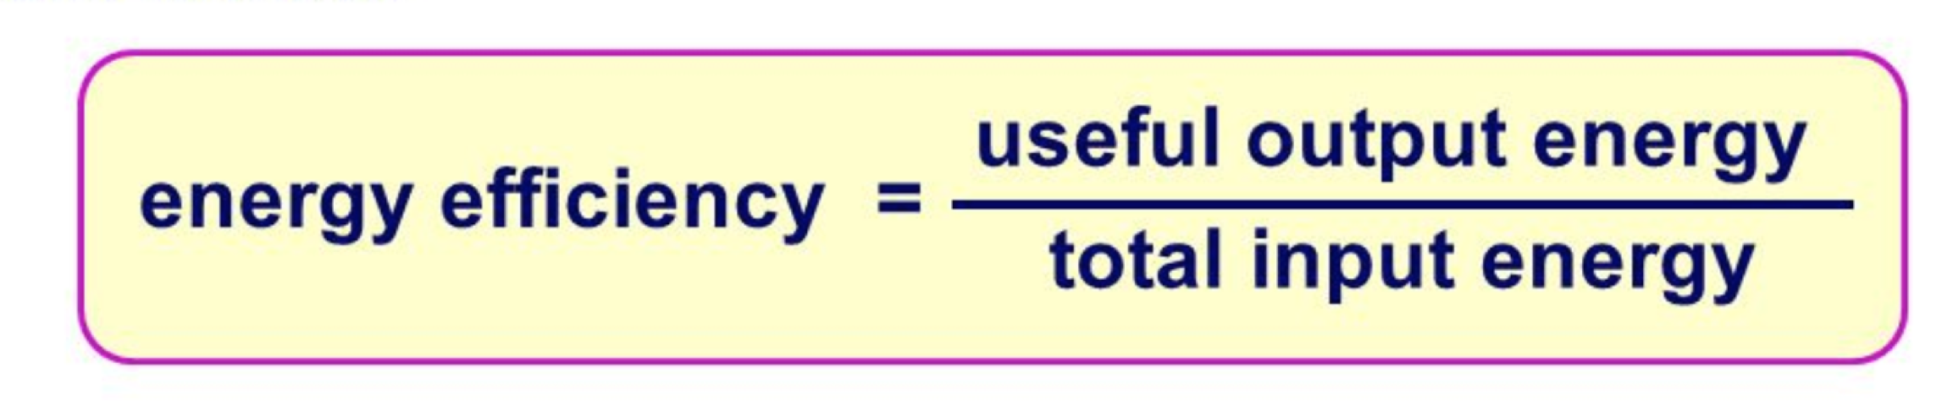

Total marks: /36

Question 1 Variables (2 Marks)

For the experiment which you conducted in class, identify the variables and place them in the space below.

Choose from the following:

Type of ball Height of bounce

1. Independent variable: __________________________________________
2. Dependent variable: ___________________________________________

**Question 2 Graphing (2 Marks)**

A student conducted the same ‘Bouncing Balls’ experiment. They bounced the ball and measured the height in centimetres of the bounce. Below is a copy of the graph they were able to draw using the data.

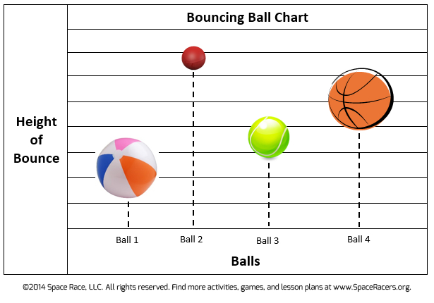

1. The graph is missing some information. Put the missing information in the appropriate place. (1 mark)
2. Which ball is the most efficient? (1 mark)

___________________________________________________________

**Question 3 Tables (9 Marks)**

Another student recorded their data in a table which is shown below.

_______________________________________________

|  |  |  |  |  |  |
| --- | --- | --- | --- | --- | --- |
| Type of ball | First bounce | Second bounce | Third bounce | Average bounce (cm) | Bounce efficiency (%) |
| Tennis ball | 17.5 cm | 18.0 cm | 20.5 cm |  |  |
| Golf ball | 39.0 cm | 39.0 cm | 37.0 cm |  |  |
| Ping pong ball | 50.0 cm | 46.0 cm | 52.0 cm |  |  |

1. Calculate the average bounce for each type of ball and enter this information into the table. (3 marks)
2. Calculate the bounce efficiency for each type of ball and enter this information into the table. (3 marks)
3. The student has made an error in their table. They have missed entering some information, and some information has been placed in the wrong place.
   * 1. The table is missing a title. Write in a good title in the space provided. (1 mark)
     2. Circle the information that is in the wrong place and draw an arrow pointing to the area where the information should have been placed. (2 marks)

**Question 4 Sankey Diagrams (5 Marks)**

Below is a picture of a Sankey Diagram showing the transformations that have occurred during the bouncing of a ball. Fill in the blanks in the following Sankey diagram to show the energy transformations from when you dropped the ball  
to when it reached its bounce height.

You can use the following words:

* Gravitational potential energy
* Elastic potential energy
* Heat energy
* Sound energy

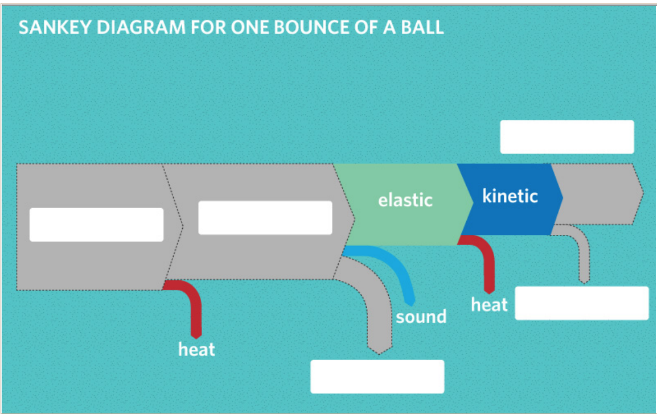

**Question 5 Energy Transfer (13 Marks: ½ Mark each)**

Complete the following table by filling in the sentences with appropriate words.

